**SAP ABAP**

**Basic Codes in SAP**

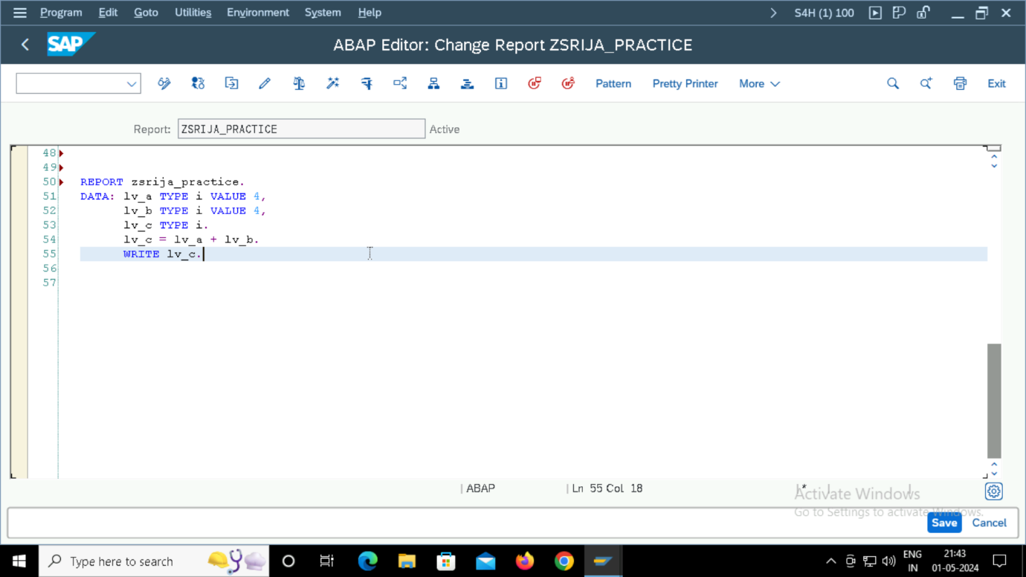

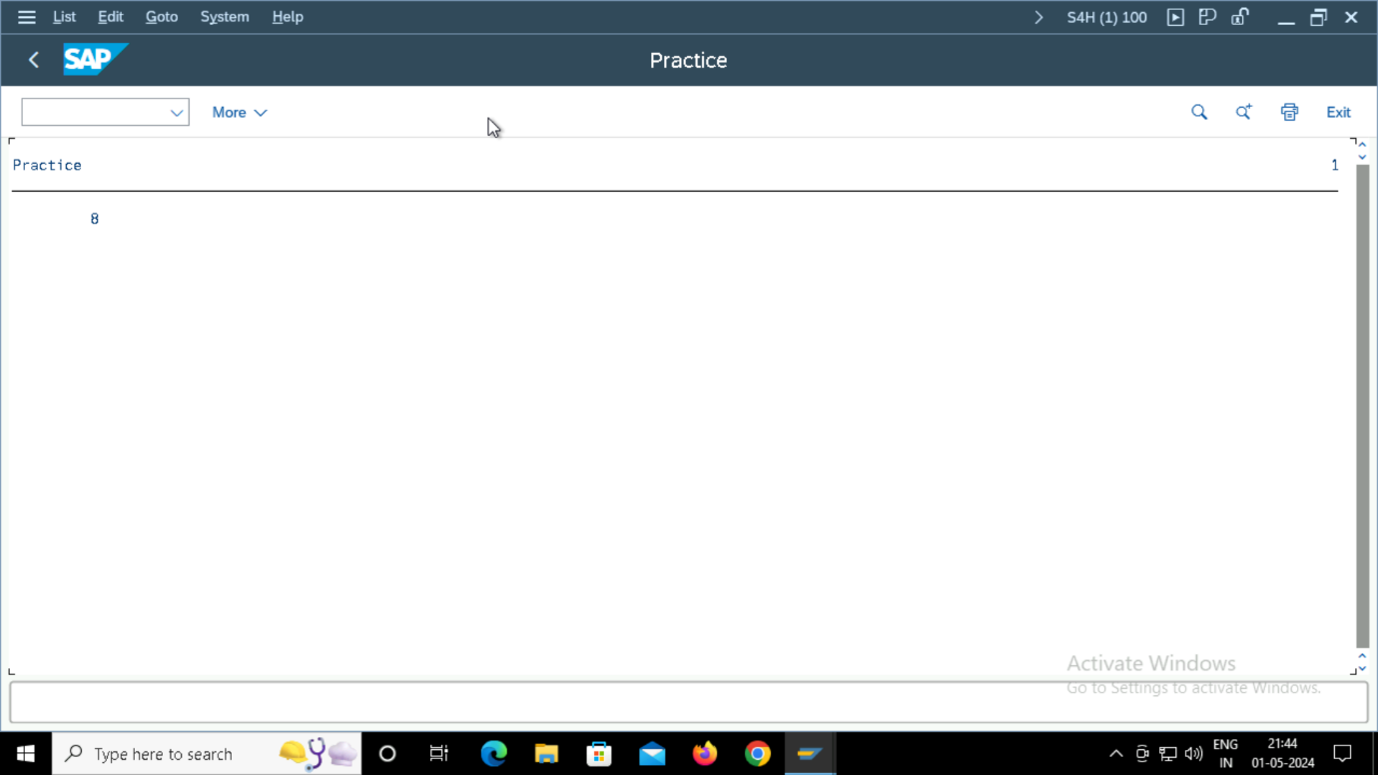

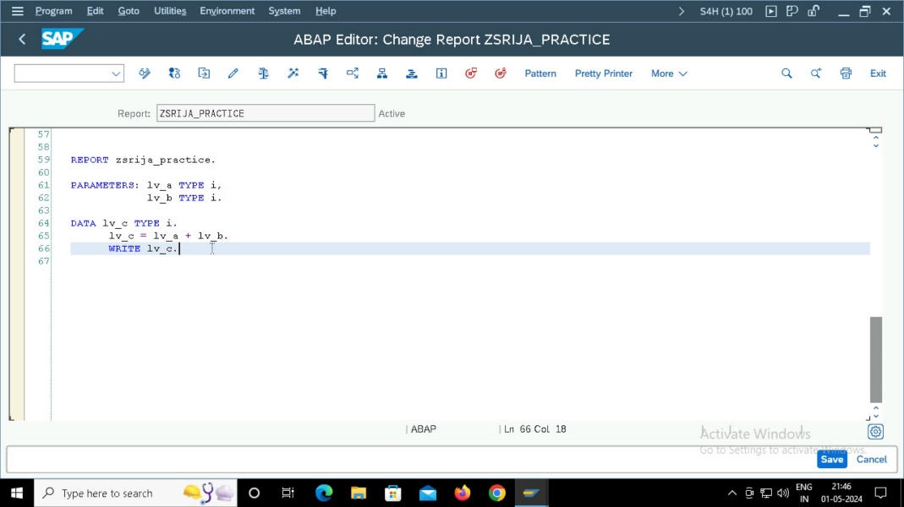

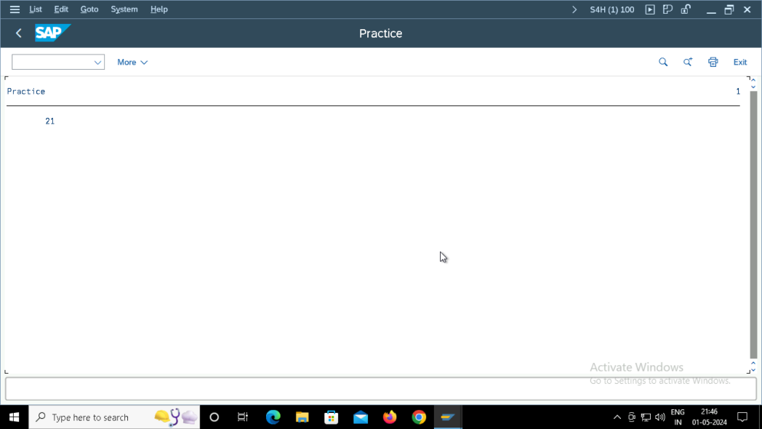

**Select Statements from kna1 table.**

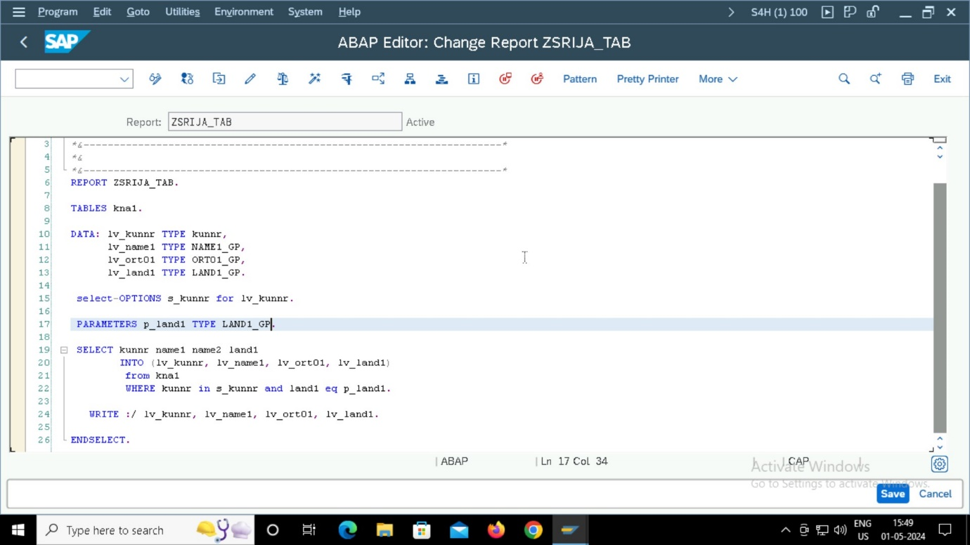

**INPUT:**

**OUTPUT:**

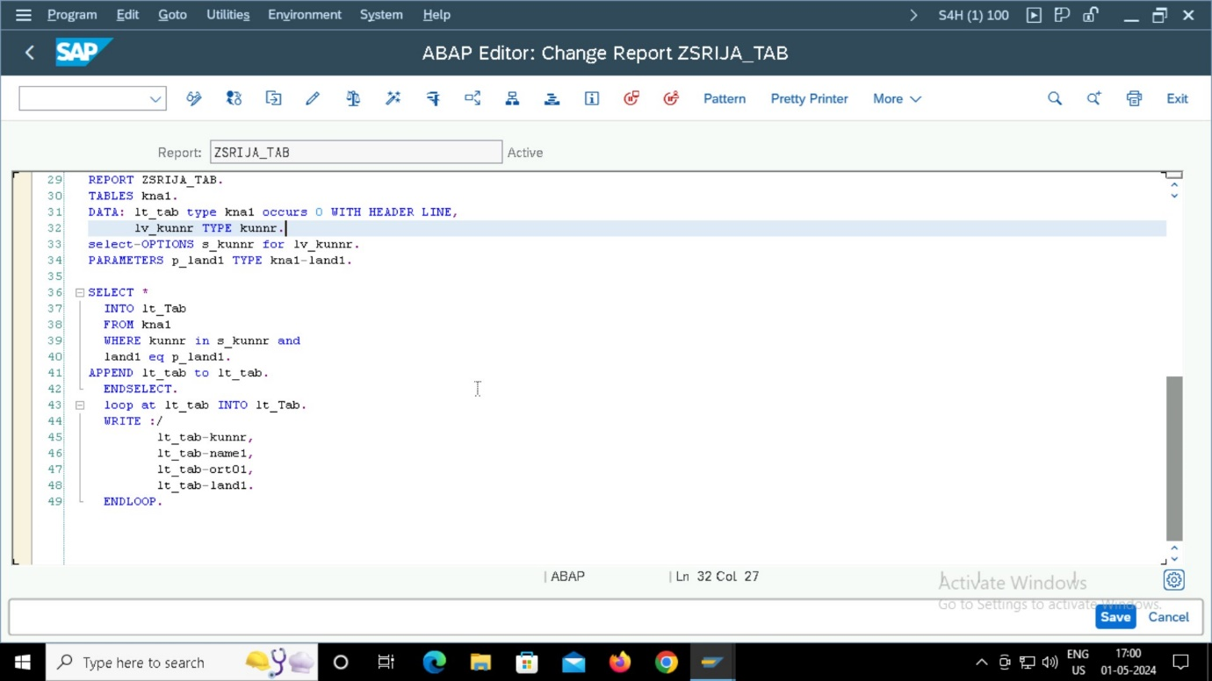

**Input:**

**Output:**

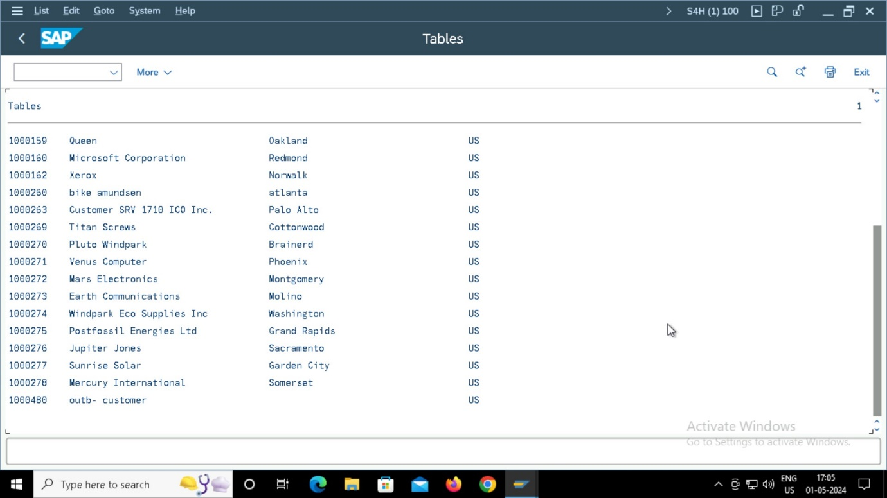

**INTERNAL TABLE:**

**FORMATTING THE TABLE**

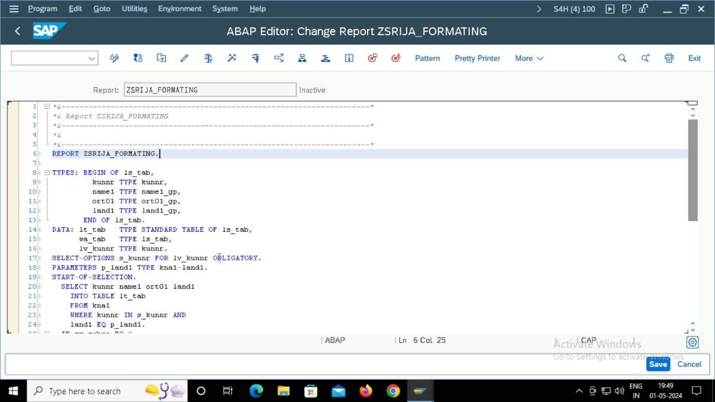

**OUTPUT:**

**INNER JOIN:**

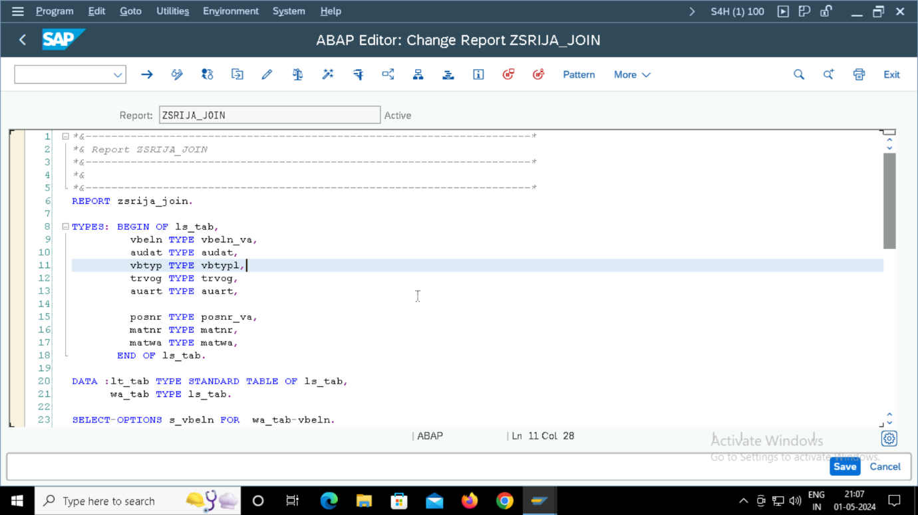

**INPUT:**

**OUTPUT:**

**TABLE CREATION :**

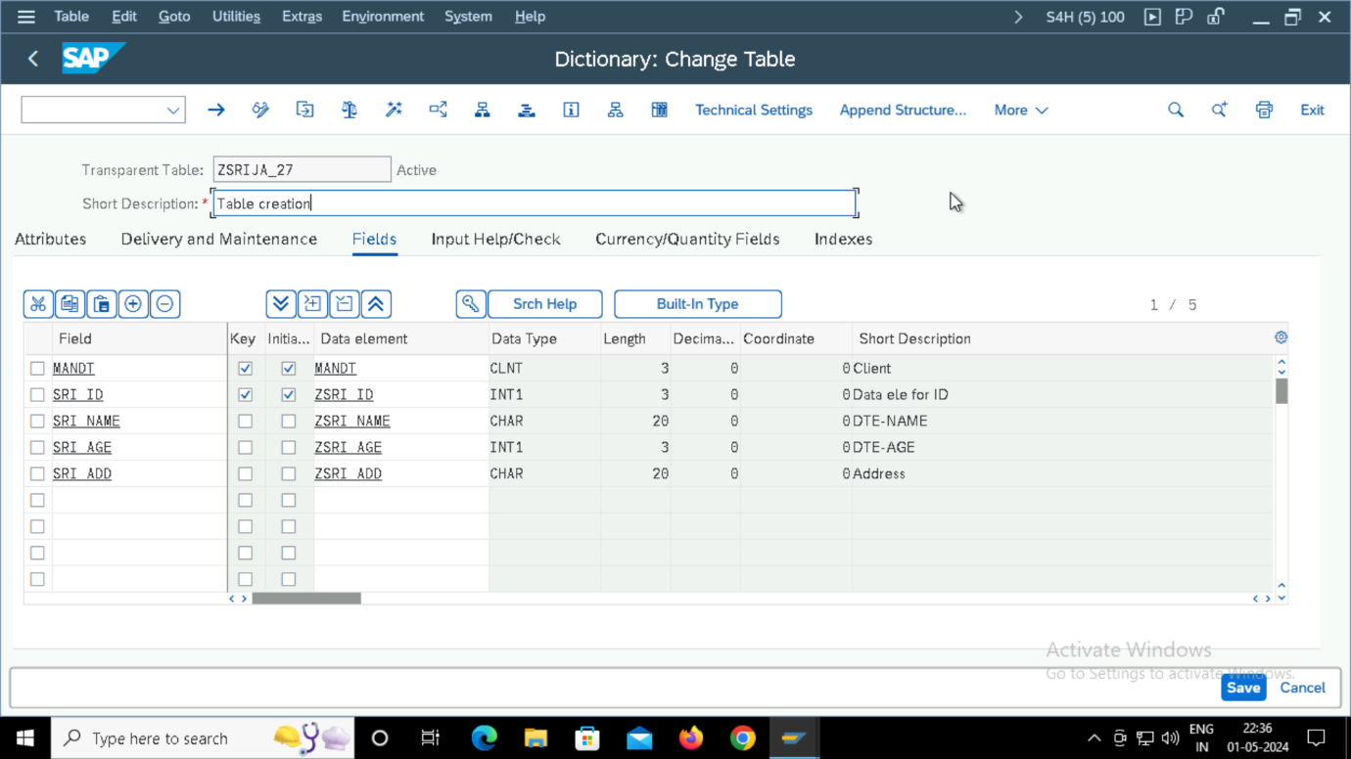

**STRING MANIPULATIONS:**

**UPPER CASE TO LOWER CASE/ LOWER CASE TO UPPER CASE:**

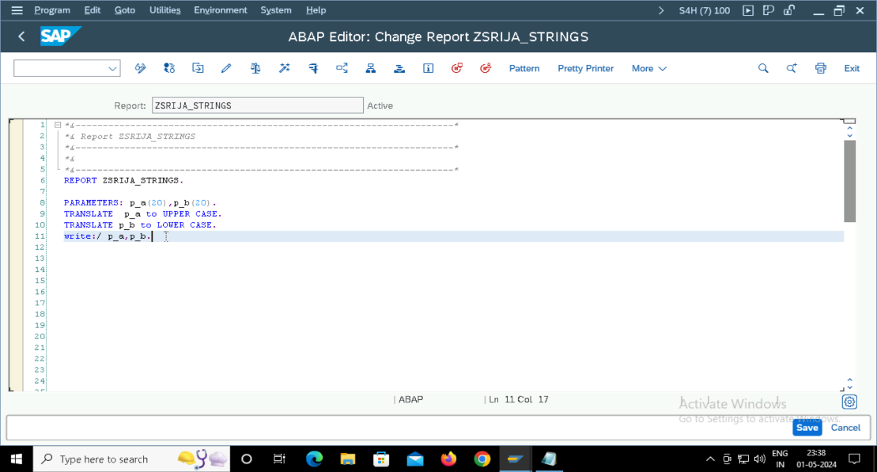

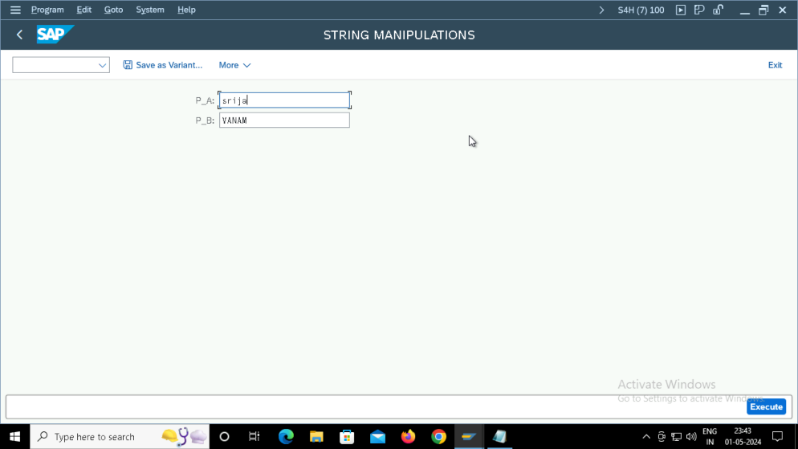

**STRING LENGTH**

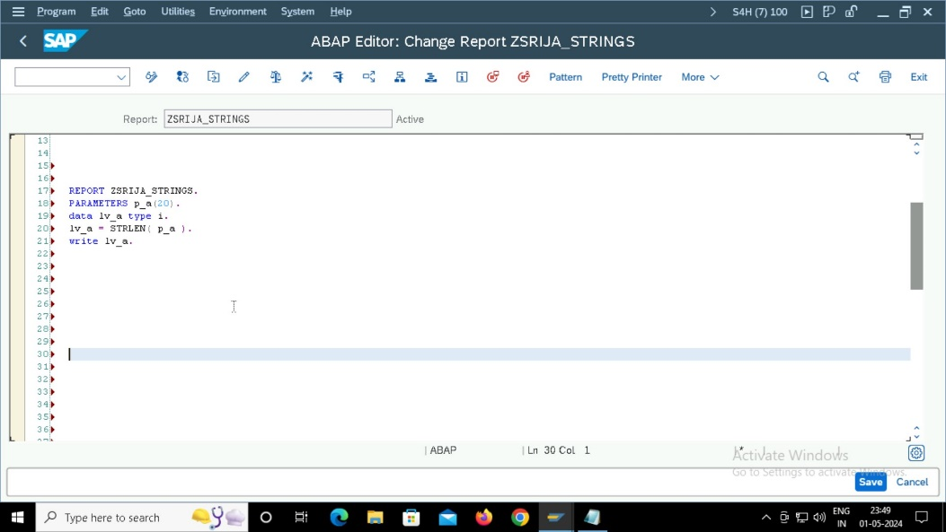

**CONCATENATE:**

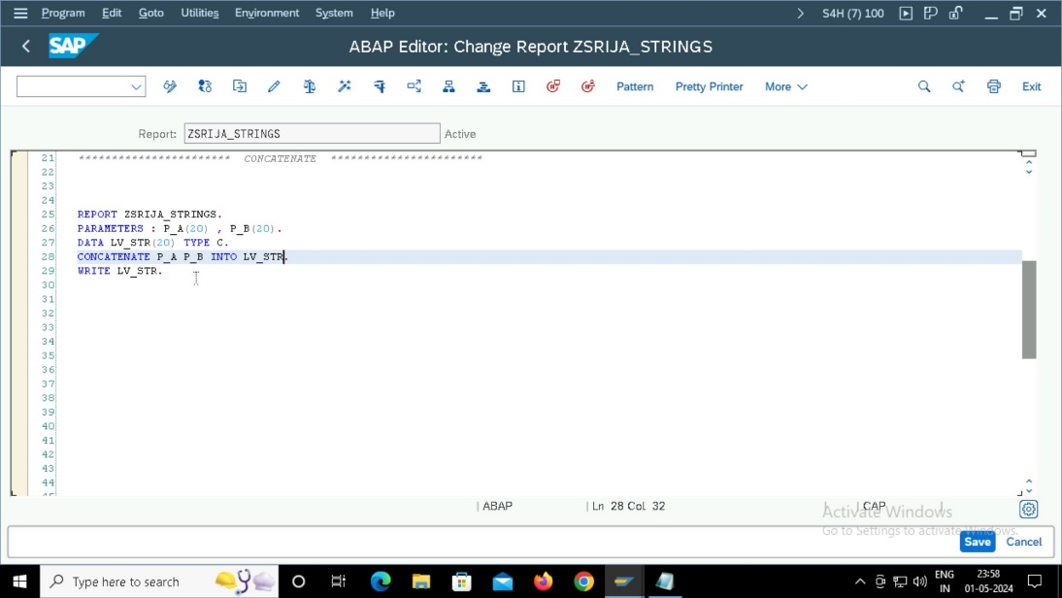

**OFFSETTING:**

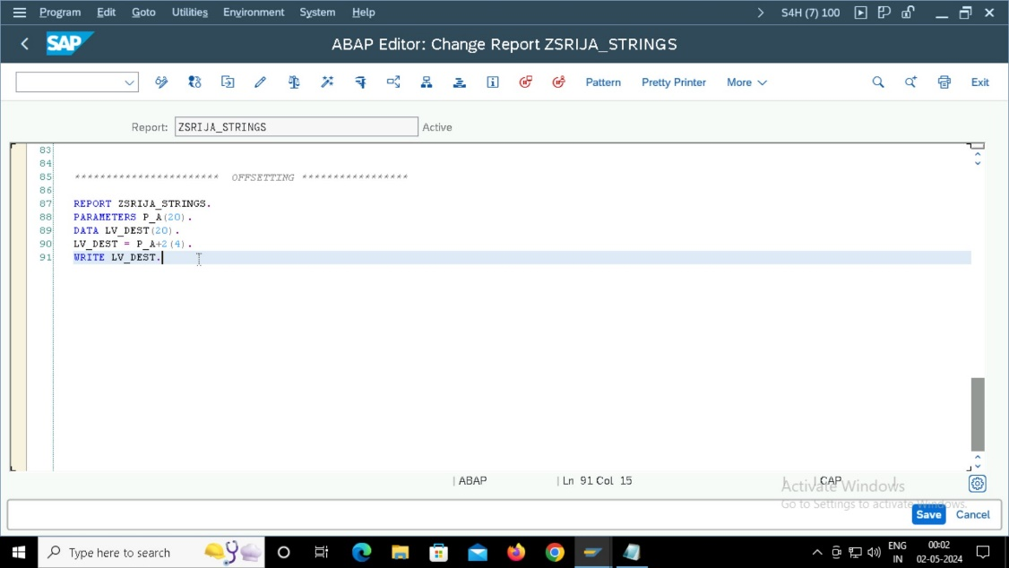

**VIEWS :**

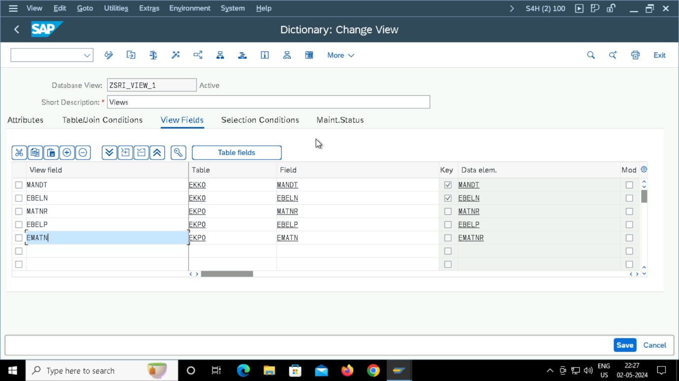

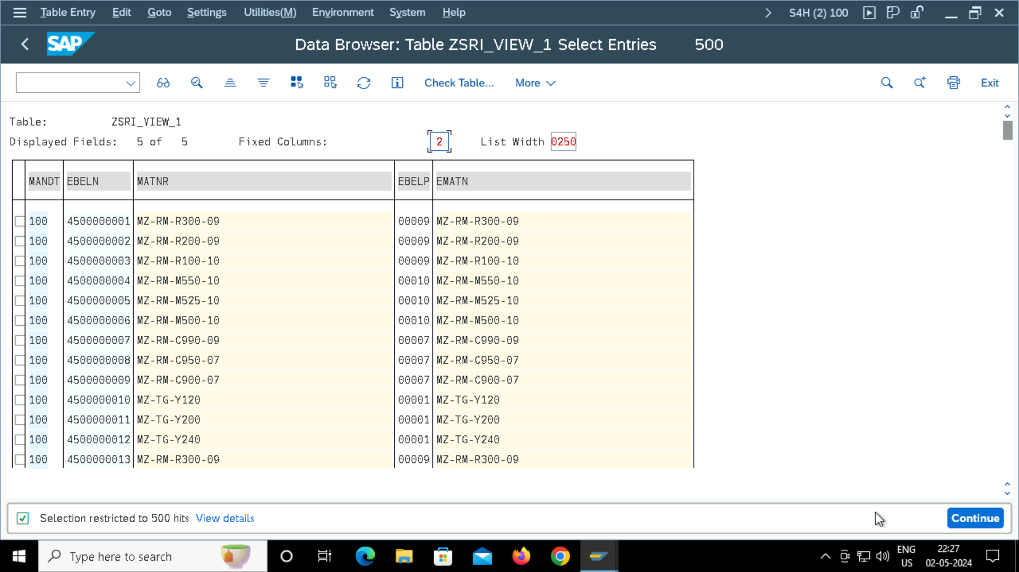

**ELEMENTARY SEARCH HELP:**

**COLLECTIVE SEARCH HELP :**

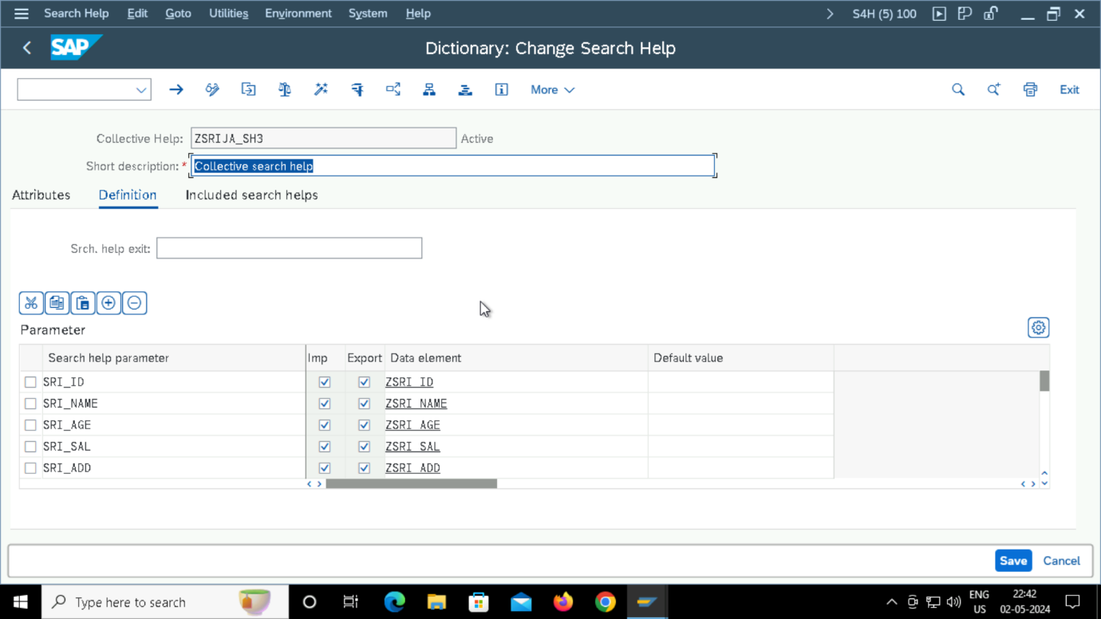

**OUTPUT:**

**STRUCTURE:**

